**Fundamentals of Accounting**

**Introduction to Accounting/Need for Accounting**

* Language of the business
* Concerned with measurement and communicating financial data
* Provide financial information for making decisions in a business entity on its activities
* The information can be provided only when transactions are recorded, summarised, classified properly
* Business transactions are huge and humans are incapable of remembering all transactions
* All organisations which require money and economic resources need accounting

**Accountancy:** Systematic knowledge of accounting. Tells us how to record, summarize and classify transactions

**Accounting:** The process of identifying, measuring and communication information to permit informed judgements and decisions by the users of the information (American Accounting Association)

**Or**

The art of recording, classifying and summarising, in a significant manner in terms of money, transactions and events which are in part, at least, of financial character and interpreting the results there of (The American Institute of Certified Public Accountants)

**Book Keeping:** Art of recording business transactions in a set of books

**Accountancy, Accounting and Book Keeping**

* Book keeping provides the basis for accounting and it is a complimentary accounting process
* Accounting begins where book keeping ends. Accountancy includes book keeping and accounting

**Difference between Book-Keeping and Accounting**

**Objectives of Accounting**

* Maintenance of records of business transactions
* Calculation of Profit and Loss
* Depiction of Financial position
* Providing accounting information to users
* To facilitate proper management of cash

**Features of Accounting or Process of Accounting**

* Identifying
* Measuring
* Recording
* Classifying
* Summarising
* Analysing and Interpreting
* Communicating

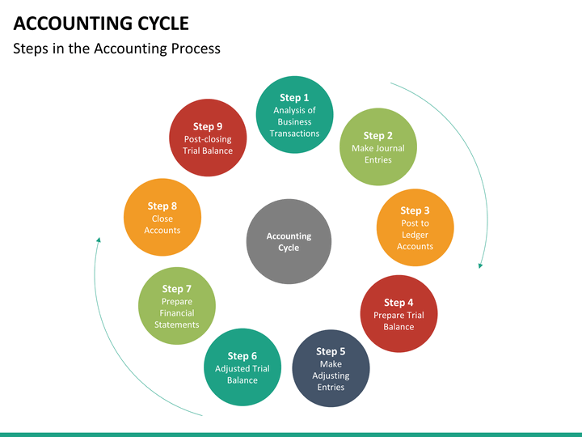**Accounting Cycle:** A series of accounting process which begins with the identification of an economic activity or transaction, recording of the economic activities and ends with the preparation or financial statements

**Importance of Accounting**

* Facilitates to comply with legal requirements.
* It shows the mode of investment for shareholders.
* It provides business trade credit for suppliers.
* It notifies the risks of loan in business for banks and lenders.
* Facilitates to replace memory.
* Facilitates to ascertain net result of operations.
* Facilitates to ascertain financial position.
* Facilitates the users to take decisions.
* Facilitates a comparative study.
* Assists the management in planning and controlling business activities and in taking decisions.
* Facilitates control over assets.
* Facilitates the settlement of tax liability.
* Facilitates the ascertainment of value of business.
* Facilitates raising of loans.
* Acts as legal evidence.

**Scope of Accounting**

The apparently divergent needs of internal and external users of accounting information have resulted in the development of sub-disciplines within the accounting discipline namely,

1. **Financial Accounting:** It is concerned with recording of business transactions in the books of accounts in such a way that operating result of a particular period and financial position on a particular date can be known.
2. **Cost Accounting:** It relates to collection, classification and ascertainment of the cost of production or job undertaken by the firm.
3. **Management Accounting:** It relates to the use of accounting data collected with the help of financial accounting and cost accounting for the purpose of policy formulation, planning, control and decision making by the management.
4. **Social Responsibility Accounting:** It is the accounting for social responsibility aspects of a business. Management is held responsible for what it contributes to the social wellbeing and progress.

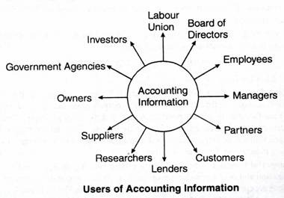

**Users of Accounting**

**Information**

**Basic Accounting Terminologies**

1. **Transactions:** Transactions are those activities of a business, which involve transfer of money or goods or services between two persons or two accounts. *For example, purchase of goods, sale of goods, etc.* Transactions are of two types, namely, cash and credit transactions.
2. **Proprietor:** A person who owns a business is called its proprietor.
3. **Capital:** It is the amount invested by the proprietor/s in the business. *For example, if Mr. Anand* starts business with Rs.5,00,000, his capital would be Rs.5,00,000.
4. **Assets:** Any physical thing or right owned that has a money value is an asset. In other words, an asset is that expenditure which results in acquiring of some property or benefits of a lasting nature. For Example, Cash in hand, plant and machinery, furniture and fittings, bank balance, debtors, Goodwill, patents, etc.
5. **Liabilities:** Liabilities refer to the financial obligations of a business. These denote the amounts which a business owes to others, e.g., loans from banks or other persons, creditors for goods supplied, etc.
6. **Drawings:** It is the amount of cash or value of goods withdrawn from the business by the proprietor for his personal use.
7. **Debtors:** A person (individual or firm) who receives a benefit without giving money or money’s worth immediately, but liable to pay in future or in due course of time is a debtor. *For example, Mr. Arul bought* goods on credit from Mr. Babe for Rest. 10,000. Mr. Arul is a debtor to Mr. Babu till he pays the value of the goods.
8. **Creditors:** A person who gives a benefit without receiving money or money’s worth immediately but to claim in future, is a creditor. The creditors are shown as a liability in the balance sheet. In the above example Mr. Babu is a creditor to Mr. Arul till he receives the value of the goods.
9. **Purchases:** Purchases refers to the amount of goods bought by a business for resale or for use in the production. Goods purchased for cash are called cash purchases. If it is purchased on credit, it is called as credit purchases.
10. **Purchases Return or Returns Outward:** When goods are returned to the suppliers due to defective quality or not as per the terms of purchase, it is called as purchases return.
11. **Sales:** Sales refers to the amount of goods sold that are already bought or manufactured by the business. When goods are sold for cash, they are cash sales but if goods are sold and payment is not received at the time of sale, it is credit sales.
12. **Sales Return or Returns Inward:** When goods are returned from the customers due to defective quality or not as per the terms of sale, it is called sales return or returns inward.
13. **Stock:** Stock includes goods unsold on a particular date.
14. **Revenue:** Revenue means the amount receivable or realized from sale of goods and earnings from interest, dividend, commission, etc.
15. **Expense:** The terms ‘expense’ refers to the amount incurred in the process of earning revenue. If the benefit of an expenditure is limited to one year, it is treated as an. Expense (also know is as revenue expenditure) such as payment of salaries and rent.
16. **Income/Profit:** Income is the difference between revenue and expense.
17. **Expenditure:** Expenditure takes place when an asset or service is acquired. The expenditure might be for a significant long-term asset (capital expenditure), a short-term asset (prepaid insurance), a reduction in a liability, or for an immediate expense such as rent (Revenue Expenditure).
18. **Voucher:** It is a written document in support of a transaction. It may be in the form of cash receipt, invoice, cash memo, bank pay-in-slip etc.
19. **Invoice:** Invoice is a business document which is prepared when one sell goods to another. The statement is prepared by the seller of goods.
20. **Receipt:** Receipt is an acknowledgement for cash received. It is issued to the party paying cash.
21. **Account:** An account is a brief history of financial transactions of a particular person or item. An account has two sides called debit side and credit side.

**Classification of Accounts**

**Accounts**

* **Personal Accounts**
* Natural Person
* Artificial Person
* Representative Persons
* **Impersonal Accounts**
* Real Accounts
* Nominal Account

**Accounting Equation**

* Assets = Equities
* Assets = Liabilities + Capital

**Generally Accepted Accounting Principles**

* The common set of accounting principles, standards and procedures that companies use to compile their financial statements.
* GAAP are a combination of authoritative standards (set by policy boards) and simply the commonly accepted ways of recording and reporting accounting information.

**Accounting Concepts**

* **Business Entity:** business enterprise and its owners are two separate independent entities
* **Money Measurement:** that all business transactions must be in terms of money, that is in the currency of a country
* **Going Concern:** business firm will continue to carry on its activities for an indefinite period of time
* **Cost:** that all assets are recorded in the books of accounts at their purchase price, which includes cost of acquisition, transportation and installation and not at its market price
* **Dual Aspect:** that every transaction has a dual effect, i.e., it affects two accounts in their respective opposite sides
* **Accounting Period:** All the transactions are recorded in the books of accounts on the assumption that profits on these transactions are to be ascertained for a specified period
* **Matching:** Though the business is a continuous affair, its continuity is artificially split into several accounting years for determining the periodical results. Thus, expenses of a particular period are compared with the revenues of that period to determine the net operational results of that accounting period
* **Realisation:** revenue from any business transaction should be included in the accounting records only when it is realised.
* **Objective Evidence:** all accounting entries should be evidenced and supported by business documents such as invoices, vouchers, etc
* **Accrual:** 
  + The Accrual concept is concerned with the recognition of both revenues and expenses.
  + The meaning of accrual is something that becomes due especially an amount of money that is yet to be paid or received at the end of the accounting period.
  + It means that revenues are recognised when they become receivable. Though cash is received or not received and the expenses are recognised when they become payable though cash is paid or not paid.

**Accounting Conventions**

The term "accounting conventions" refer to the customs or traditions, which are used as a guide in the preparation of meaningful financial records in the form of the income statement (Profit and Loss Account) and the position statement (Balance Sheet).

* **Convention of consistency**: the accounting practices and methods should remain the consistent from one accounting year to another.
* **Convention of full disclosure:** that all material and relevant facts concerning financial statements should be fully disclosed.
* Adequate
* Fair
* Full
* **Convention of materiality:** to make financial statements meaningful, only material fact i.e. important and relevant information should be supplied to the users of accounting information
* **Convention of conservatism**: profit should not be recorded until it is realised. But if the business anticipates any loss in the near future, provision should be made in the books of accounts for the same.

**Advantages of Journal**

* Each transaction is recorded as soon as it takes place. So, there is no possibility of any transaction being omitted from the books of account.
* Since the transactions are kept recorded in journal, chronologically with narration, it can be easily ascertained when and why a transaction has taken place.
* For each and every transaction which of the two concerned accounts will be debited and which account credited, are clearly written in journal.
* So, there is no possibility of committing any mistake in writing the ledger.
* Since all the debits of transaction are recorded in journal, it is not necessary to repeat them in ledger. As a result, ledger is kept tidy and brief.
* Journal shows the complete story of a transaction in one entry.
* Any mistake in ledger can be easily detected with the help of journal.

**Features of Ledger**

* Ledger is an account book that contains various accounts to which various business transactions of a business enterprise are posted.
* It is an analytical record of transactions.
* It is a derived or secondary record.
* It is a book of final entry.
* It is the principle book of accounts. It is rightly called the king of books of accounts.
* It is a permanent record of transactions.
* It is the ‘reference book of accounting system

**Importance of Ledger**

* Knowledge of Business results
* Knowledge of book value of assets
* Useful for management
* Knowledge of Financial Position
* Instant Information
* Arithmetical Accuracy

**Posting:** The process of transferring the entries recorded in the journal or subsidiary books to the respective accounts opened in the ledger

**Difference between a journal and a ledger**

|  |  |  |
| --- | --- | --- |
| **Basis of Distinction** | **Journal** | **Ledger** |
| Nature of Book | Book of original or prime entry | Book of final entry or secondary entry |
| Basis for Preparation | Source Documents | Journal |
| Stage of Recording | First | Second |
| Objective of Preparation | To record all transactions in chronological order | To know the net effect of various transactions affecting a particular account |
| Format | 5 columns | 4 columns |
| Narration | Yes | No |
| Process of recording entries | Journalising | Posting |
| Tax authorities | Do not rely of these books | Rely on these books for assessment purpose |

**Balancing an account**

* Balance is the difference between the total debits and the total credits of an account.
* Balancing means the writing of the difference between the amount columns of the two sides in the lighter (smaller total) side, so that the grand totals of the two sides become equal.

**Trial Balance**

* Trial balance is a statement which shows debit balances and credit balances of all accounts in the ledger.
* “Trial balance is a statement, prepared with the debit and credit balances of ledger accounts to test the arithmetical accuracy of the books” – J.R. Baltiboi

**Objectives of Trial Balance**

* To check the arithmetical accuracy of the ledger accounts.
* To locate the errors.
* To facilitate the preparation of final accounts.